Creating Interview Types
Objective
After completing this lesson, you will be able to create interview types to standardize the interview process and provide clarity for interviewers and candidates.
Interview Types
Effectively managing and standardizing the interview process is crucial for making informed hiring decisions. SmartRecruiters provides tools to configure interview types and scorecards, ensuring consistency and focus during candidate evaluations. Interview types help categorize different interview formats, such as phone screens, in-person interviews, or panel interviews. For example, when a member of the hiring team schedules an interview, they can assign each time slot an Interview Type, a configurable label that describes the purpose and/or format of an interview time slot (for example, Phone Screen, Technical Interview, On-site).
Creating interview types ensures your team can easily select the appropriate type, streamlining scheduling and providing clarity for both interviewers and candidates.
Benefits of Using Interview Types
- Clarity and context for everyone: Selecting an interview type assigns a clear, standardized label to the slot, so interviewers (and your team) immediately understand the intent of that segment.
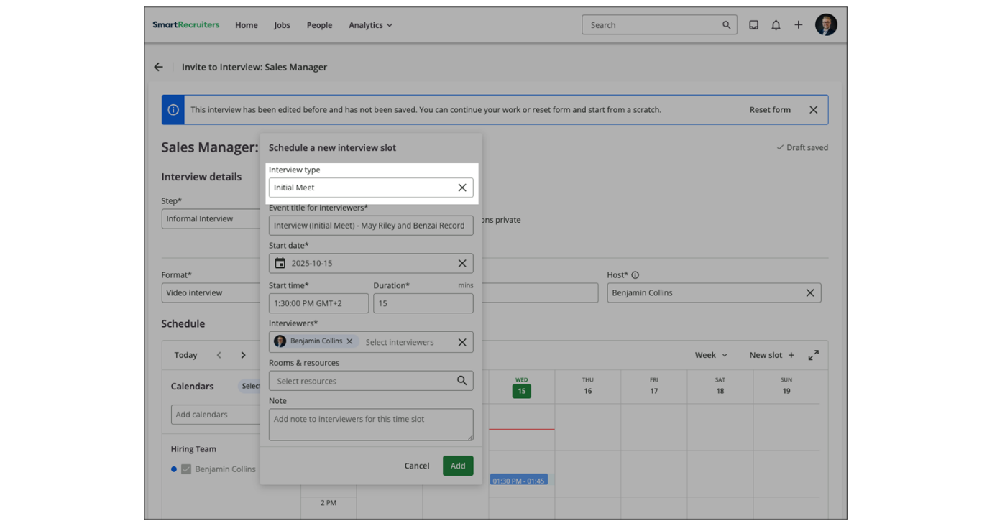
- Cleaner, more personalized communications: An interview type token [m_interview_type] is available as a merge field in email templates under the Add merge field menu, allowing interview invitations and reminders to automatically display the interview type without manual updates.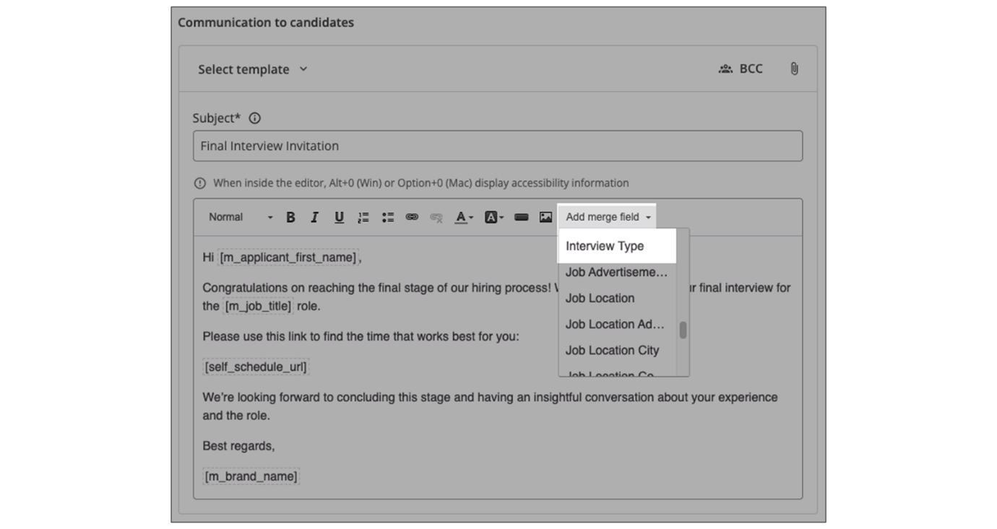
- Consistent candidate experience in self-scheduling: Sending Self-Scheduling invites and aligning Interview Type with the selected Format/Location helps avoid confusing calendar subjects for candidates (such as Phone vs. On-site).
Configure Interview Types
Steps
- Navigate to Settings/Admin→Configuration→Interview Types.
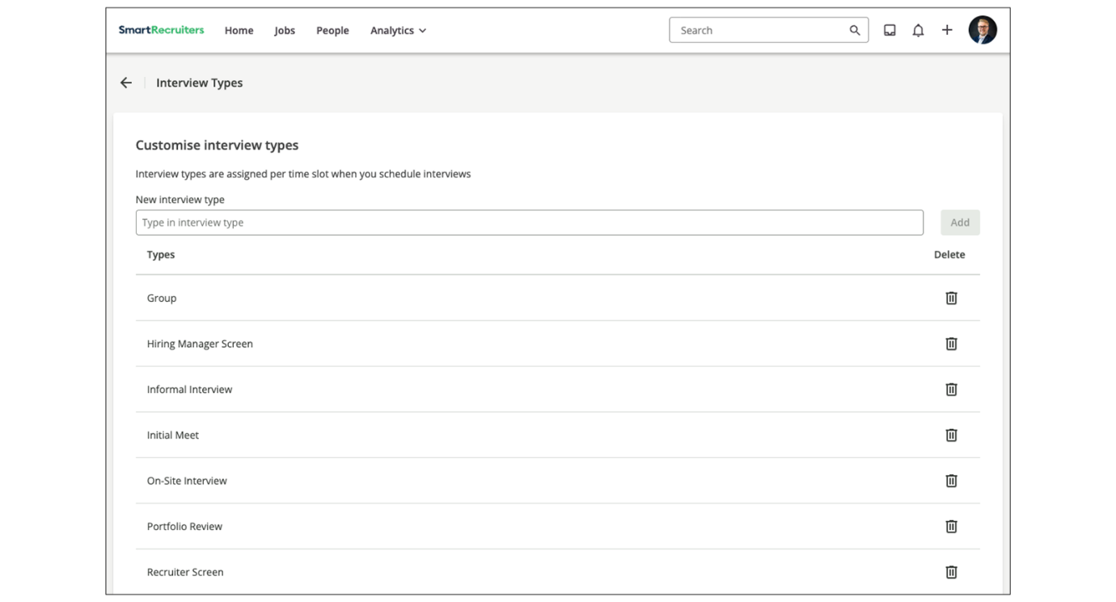
- Review the list of existing interview types and remove any that are no longer relevant.
- Add a new interview type by entering a name (for example, Phone Screen) and saving it.
- Select the newly added interview type when scheduling interviews.
Gain more insight by watching this video!
This video is for demonstration purposes. Any references made in this video to previous or later videos in this course (including titles, numbers, links, or sequence) may differ from the current course structure. Additionally, some functionalities shown may have evolved over time due to ongoing enhancements or business decisions.
Summary
- Interview types help categorize different interview formats, such as phone screens, in-person interviews, or panel interviews.
- Configuring interview types provides clarity and context for everyone involved in the hiring process.
- Interview types can be added, removed, and managed within the SmartRecruiters platform under Settings/Admin→Configuration→Interview Types.
- Interview types can be used in email templates to create cleaner, more personalized communications.
Welcome to this lesson on
interview types in SmartRecruiters. So, when somebody is scheduling
an interview with a candidate they can come through and pick
the time slot that they're looking to schedule that for and within
the details of that interview they can select an interview type. So
the list of interview types you have here there'll be some standard
ones available in the system for you but you can edit these
as required and add your own interview types as needed. So to do
that we're going to go through to Settings and Admin and underneath
Configuration, Interview types. In here you'll see a list that already
exists for you and you can come through and remove any that are
not relevant and of course add your own interview type. So I'm going
to add one here for a phone screen and then add that into my list. So
fully editable you can update these as needed and then once that
interview type has been added to your list it will be available for
your team to select from when they schedule interviews. That ends this
lesson on interview types. Thank you.

Configuring and Working with Interview Templates
Objective
After completing this lesson, you will be able to configure individual and group interview templates to standardize recruitment workflows and automate candidate scheduling.
Interview Templates
Interview templates in SmartRecruiters help standardize and streamline your hiring process. They let you preconfigure interview settings, automate scheduling, and deliver a better experience for both the recruiting team and candidates.
These templates capture essential details for each interview step, such as interview duration, the required number of interviewers, communication settings (including email templates), and additional options like interview format and location. Using interview templates ensures consistency and efficiency in scheduling and conducting interviews.
Interview templates are useful in any recruitment process, but they are especially valuable for high-volume hiring. They enable candidates to self-schedule both individual and group interviews with minimal involvement from the hiring team, while still ensuring that the right interview type and the right interviewers are scheduled, creating a smooth, consistent experience for candidates.
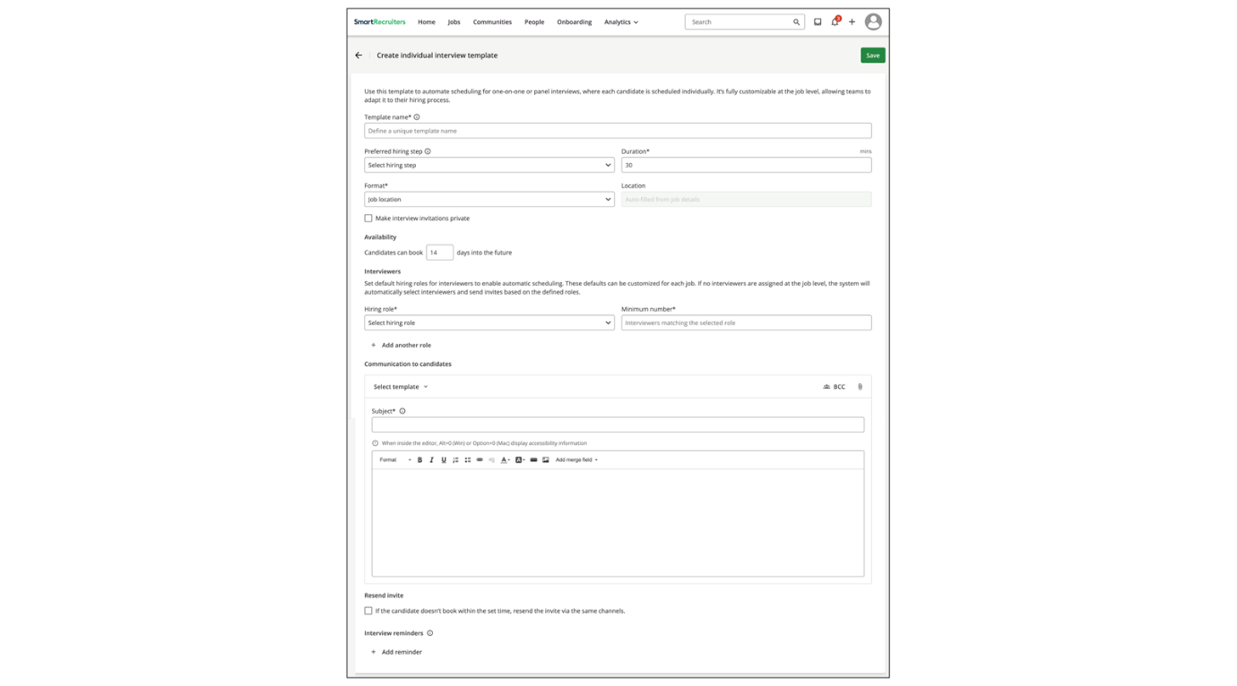
Key Components of an Interview Template:
- Interview Duration: Specify the length of the interview to allocate appropriate time slots.
- Minimum number of Interviewers: Assign the required minimum number of interviewers from your hiring team. The system can automatically select available interviewers based on their availability and scheduling preferences.
- Communication Settings: Link email templates or define custom email subjects, bodies, and attachments for candidate invitations, reminders, and follow-ups.
- Additional Settings: Configure options like interview format (for example, video, in-person, phone), location, and whether the invitation should be private.
Create an Individual Interview Template
Steps
- Navigate to User Menu→Settings.
- Select Interview Templates in the Templates section.
- Select Add Template.
- Enter a name for the template and configure the required fields, such as the preferred hiring step and interview duration.
- Specify the number of interviewers (up to 20) and their hiring team roles. You can select anyone on the hiring team or assign specific standard or custom roles.
- Include additional details such as the interview format, location, communication template, interview reminders, or set invitations as private.
- Review the details and save the template for use in your hiring processes.
Create a Group Interview Template
This template is used to automate scheduling for group interviews, where multiple candidates are invited to shared sessions.
Steps
- Navigate to Interview Templates.
- Select User Menu→Settings.
- Select Interview Templates.
- Create a new template by selecting Add Template.
- Select Group Interview from the dropdown menu.
- Enter a name and select a preferred hiring step.
- Choose whether calendar invitations should be private.
- Define Time Slots:
Select the days and add time slots during which group interviews can be scheduled. Multiple slots per day can be added by selecting Add another time. The setup can be configured to repeat on a regular schedule or run as a one-off.
- Set Slot Details:
Select the capacity, duration per interview slot, format, and location for each slot.
- Define Interviewers:
Specify the number of interviewers (up to 20) and their hiring team roles.
- Add Communication Template:
Add a group interview communication template or create your own email within the group interview template.
- Decide if you want to resend the invite if the candidate doesn't book an interview within 24, 48 or 72 hours and enter the number of resend attempts.
- Decide if you want to set up a reminder to be sent X hours before the interview.
- Save the Template.
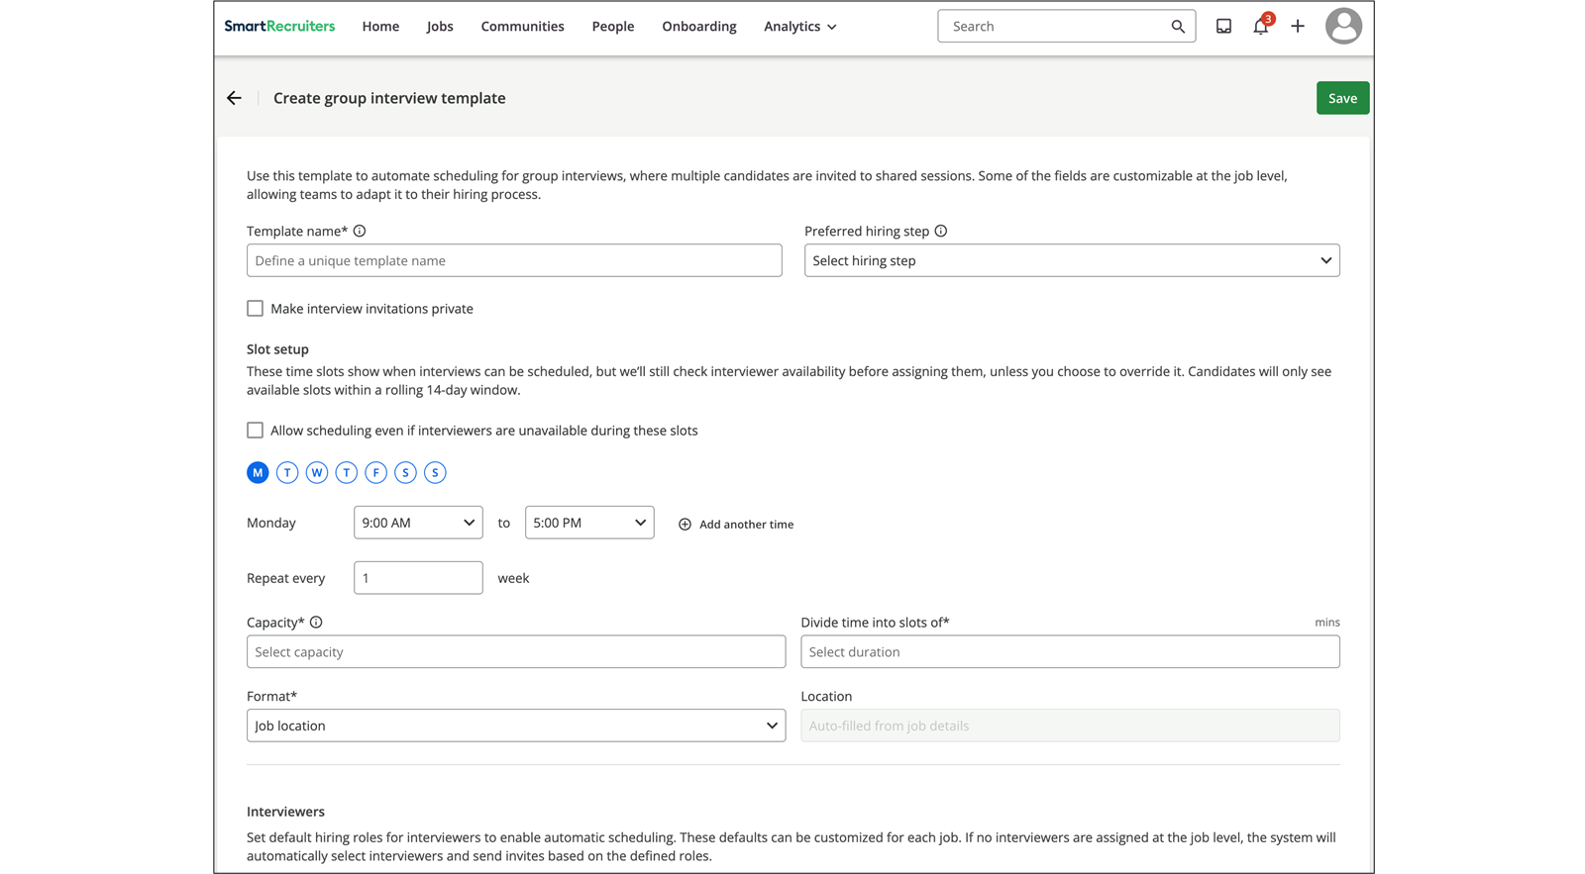
Watch this video on the topic of creating Group Interview Templates for more details.
This video is for demonstration purposes. Any references made in this video to previous or later videos in this course (including titles, numbers, links, or sequence) may differ from the current course structure. Additionally, some functionalities shown may have evolved over time due to ongoing enhancements or business decisions.
Edit Interview Templates Attached to a Standard Hiring Step
Efficiently managing interview templates ensures alignment with your organization's hiring process. You can configure and customize interview templates for standard hiring process steps.
Steps
- Select User Menu→Settings.
- Select Hiring process in the Configuration section.
- Select the specific hiring process you wish to modify.
- Select the Edit icon.
- Locate the step with the default attached template and select Manage Interview Templates.
- Preview, edit, or replace the template with another template.
Edit Interview Templates Attached to a Custom Hiring Step
You can also configure and customize interview templates for custom hiring process steps.
Steps
- Identify which custom process steps involve a candidate interview. Custom process steps may or may not involve interviews.
- Select Manage steps and choose the custom step name for each step that includes an interview.
- Confirm that the selected interview-related custom steps appear on the main page.
- Assign an interview template to the step by selecting the + button.
Interview Template Filtering
When selecting or replacing an interview template, the list is filtered to show only the most relevant templates for the current hiring step:
- Matching templates: Templates assigned to the current hiring step.
- Neutral templates: Templates not linked to any preferred step or marked as custom.
- Irrelevant templates hidden: Templates assigned to a different hiring step are hidden to avoid confusion.
This filtering makes it easier to find the right template, especially in organizations with many templates.
Watch the video below to learn about how to create interview templates for automated self-scheduling.
This video is for demonstration purposes. Any references made in this video to previous or later videos in this course (including titles, numbers, links, or sequence) may differ from the current course structure. Additionally, some functionalities shown may have evolved over time due to ongoing enhancements or business decisions.
Manage Interview Settings for a Single Job
Customizing interview settings for individual jobs ensures alignment with specific role requirements and hiring team preferences.
Each job inherits default interview templates linked to its associated hiring process. To review or adjust these templates for a specific job:
Steps
- Select Jobs.
- Select the job for which you want to adjust interview templates.
- Open theHiring Process tab and scroll to the Auto Self schedule section.
- Mark the custom steps that involve a candidate interview by selecting Manage steps and choosing the appropriate step names.
- Assign a different interview template to a step or edit the interview settings for steps with job specific default values, as needed.
- Edit an assigned template by selecting the pen icon next to the template name.
You can override the default values defined in the original template for parameters like format, location, organizer, duration, communication email invite, SMS/WhatsApp communication email invite, and reminders.
Note
The organizer will be marked as the event owner on the calendar invite and will serve as the Zoom host if Zoom is selected as the interview format.
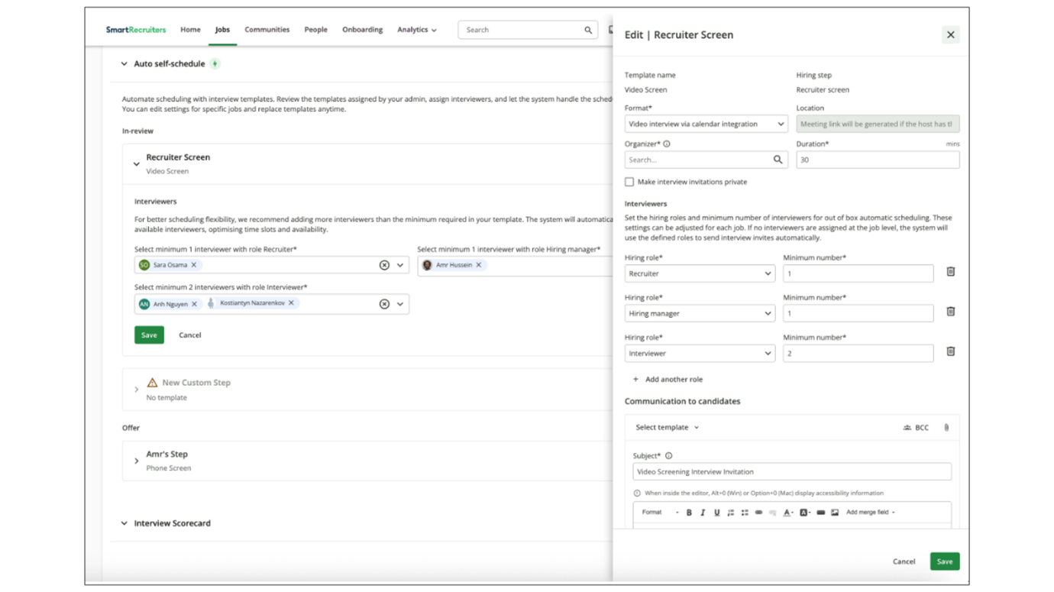
Summary
- Create interview templates to standardize the interview process, including setting duration, interviewers, and communication.
- Manage and customize templates for both standard and custom hiring steps, ensuring alignment with organizational needs.
- Manage interview template settings for a single job.
In this video, we're going
to review how to create automated group interview
templates in SmartRecruiters. Automated group interviews allow
recruiters to create group interview sessions and invite candidates
to self-schedule themselves into their desired session time. The
first step in creating group interview templates is to create
the group interview communication template which will be used later
when creating the interview template. To create the communication
template, select the Communication Template, located under the Templates
section on the Settings page. On the Communication
Templates page, click the Add Template button in
the top right corner. First, you need to select the
Communication Template type. Click on the Type drop-down and select Invitation to Automated Group Interview. Next, you'll give this template
a name, and then you can decide if you want this template to
apply to specific org fields. For now, we'll have this
template apply to all org fields. you have the option to create
both an email interview invite and an SMS invite for the email invite.
I'm quickly going to enter the subject line and message content.
When you're creating your email message, you want to make sure that
you have included the group URL merge field. This field is going to
generate the link for the candidate to self-schedule themselves into
the group interview. To add an SMS invite, click the smart message
option and write your message. Also remember to include the group
URL merge field so candidates can self-schedule. For now, we're only
going to create the email invite. When you're done, click
the Save Template button. Back on the Communication
Template page, you'll see the Group Interview
Template ready to go. Now that we've created the Group
Interview Communication Template, it's time to configure the Group Interview
Template. Under the Templates section on the Settings page, select
the Interview Templates option. On the Interview Template page, click
the Add template button located at the top right of the page and select
the Group interview option on the Group Interview page. We'll first
give this interview template a name and then decide if we want to add
this template to a predefined hiring step. Since this is a custom template
we don't have to assign this template to a step right away and we'll be
able to assign this template within a hiring process or at the job
level later on like with individual interview templates we can decide
to make the invitations private, and then we're going to set up the group
interview slots. The group interview slot is the chunk of time in which
the individual group interview sessions can take place. By default,
if an interviewer is not available for a session, the session will
not be available for candidates to schedule. However, we do have the
option to allow sessions to still be scheduled if an interviewer is
unavailable during that time. For this template, we're going to have group
interviews conducted on Mondays and Wednesdays. On Mondays, we're going
to have the group interview slot be from 9 a.m. to 1 p.m. You have the
option to add another time slot on that day by clicking the Add another
time slot option and then choosing the time in which that slot will take
place. For example, on Mondays there is also an afternoon slot for group
interviews to be scheduled. So we're going to add an additional slot
of time between 3 p.m. and 5 p.m. To remove a time slot, click
the Remove time option. Next we're going to select how often
this slot repeats. We want this to repeat every Monday so we're going
to choose repeat every one week. Then we're going to choose the capacity
for how many candidates can join the group session. We'll set the
capacity at 10 candidates per session and then we'll select the session
length, which will be 30 minutes. So within this 9 a.m. to 1 p.m.
time slot, the group interviews will be divided into 30 minute
sessions. For the Monday sessions we're going to have the interviews
on site so for the format option we're going to select job
location and then the location field will pre-populate with
the location information from the job details. On Wednesdays our
group interviews will be virtual and the time slot for those
will be from 12 p.m. to 4 p.m. Again we will have this repeat
every week and we'll keep the capacity and session length the
same as the Monday sessions. Since this will be the virtual
option, the format will be a video interview via a calendar
integration. If you don't have a calendar integration
or if you would rather use a different meeting link you can also choose the other video option and then paste
the link in the location field. Since these sessions will
be created using a calendar integration, the meeting.
link will be automatically generated using the
meeting host's calendar. Next, we're going to select the
default hiring roles that will be automatically added as the interviewers
and you can change who the specific interviewers will be on the job level.
We're going to want at least two hiring managers added to this
interview as well as two interviewers. Then we're going to
choose the communication template that will be sent to candidates. On the template dropdown,
we're going to select the Group communication template we
just created. You also can choose to add attachments to
this, or you can add a blind copy if you need to send
this to other team members. Also, if an SMS template wasn't set
up in the initial group communication template, you can add one here by
clicking the Add a Smart Message Invite option. When adding a Smart
Message invite on this page, the self-scheduling link will be added
to the end of the message so you only need to enter the message content
in the field. You can also add a confirmation message that will be
sent once the candidate has scheduled. The date and location
of the interview will be added automatically
to the end of the text. When you're done, click the Save button at the top right of the screen. Back on the Interview
Templates page, we'll see our Group Interview Template,
and we have the option to copy, edit, or delete
our template if needed. In our next video, we'll
be reviewing how to send and manage automated
group interviews.

In this video we're going to
be looking at how to configure your interview templates for
automated self-scheduling. As a reminder when it comes to
automated self-scheduling there are two types of templates that need
to be created. In a previous video we reviewed how to create the
communication templates necessary for automated self-scheduling
which are used when creating custom interview templates, interview
reminders, and reschedule templates. In this video we're going to
look at the second type of template, an interview
template, which is assigned to a specific interview hiring step
within the hiring process, and is sent to the candidate to
self-schedule an interview. To view your interview
templates, navigate to the Settings page and select
the Interview Templates option, located under
the Templates section. Interview templates are going to
be templates that you can assign to hiring steps in the hiring
process that include an interview. Assigning these templates
to hiring steps allows you to automate the sending of
self-scheduling invites to candidates using workflows
within the hiring process. It also gives hiring teams
the ability to quickly send the appropriate self-schedule
invite to a candidate depending on what step they're
in within the hiring process. These templates are also editable
at the job level, without changing the defaulted templates we see
here. There are several default interview templates already created
for you, and each of these are assigned to the corresponding
default hiring step in the system. These templates can't
be deleted, but you can edit them to better fit
your organization's needs. Let's go ahead and look at
the video interview template. The first section of the template
has to do with the actual interview meeting itself.
There's the template name and the preferred hiring step
that this template is assigned to, which in this case is the
default video interview step. You can choose the meeting
duration, as well as the meeting format and location,
and these can all be edited by the hiring team
at the job level as well. So although this is a default template, it can be customized for the role. If interviews within this step
are for more sensitive roles, you can choose to make the interview
invitation private. Next you'll need to assign which people from
the hiring team will be invited to the interview as well as the
minimum number of interviewers needed. If you don't assign a
hiring team role for the interview then the template will default to
selecting anyone from the hiring team as the interviewers but if
you know that the interviewers for this role will be those assigned
as hiring managers on the job then you can select the hiring
manager option from the drop down. So for this example, we are saying
that for this interview, the system will assign a minimum of two hiring
managers from the hiring team to have their calendar availability
used when creating self-scheduled slots for the candidate to choose
from when scheduling the interview. Also remember that users
can select who those hiring managers will be on the job
level, but for the default interview template, we can only
assign the hiring team role of the interviewer and not
the interviewer themselves. We can also assign multiple
hiring team roles as interviewers by clicking
the add another role option. So if we also wanted the interviewer
role assigned to this interview then we can select interviewer
from the drop-down list and then choose the minimum number of
interviewers. To remove a hiring role from the interview click the trash icon
to the right of the hiring role. After the interview logistics have
been set you can then configure the email template and although this
is a default template you can edit it to fit your needs. You can also
choose to add a templated interview reminder if you have custom hiring
steps that include interviews. You can create a custom interview
template that you will be able to assign to the appropriate hiring
step. To add a new template, click the Add template button at the top right
of the page. Let's quickly create an interview template for a custom
step called Manager Interview. For the preferred hiring step, we're
going to leave this blank since the steps listed in this drop-down are
all default. So we can assign this template to the custom hiring step.
At the job level, we'll set the duration at 30 minutes and for the
format we'll select phone interview. For the interviewers we'll assign
the hiring manager as the role and set two as the minimum. Now
we're going to select the template. When you click the template dropdown, you'll see the communication template that we created earlier.
We're going to select this template and then edit it as needed for
this hiring step. Also make sure that the self-schedule URL merge
field is included within the template so that candidates are able to
get to the self-schedule page. You can choose to also send
this invite via SMS or WhatsApp, and while you can create
your own SMS message, the WhatsApp message is pre
-configured and cannot be edited. For the SMS invite, you can write
a brief message and the self-scheduling link will automatically
be added to the end of the text. You can also include a confirmation
message that is sent to the candidate after they
schedule, where the interview date and location will be automatically
added after the text. Finally, you can add an interview
reminder to your template. First, you can select the
type of message that will be sent, and then select
the interview reminder template we created earlier
from the template dropdown. You can edit the message
as needed, and then you can select the
reminder delivery times. If you want to send an additional
reminder message, click the add reminder option and repeat the
same steps. For this interview template, I'm going to also add an
SMS reminder. I'm going to select the SMS interview reminder template
from the drop-down and then select the same delivery times as
the email reminder so the candidate will receive both an email and
SMS reminder for the interview. When you're done, click the Save
button at the top right of the page. If you are editing an
already existing template, note that any changes made will only be reflected on new
interviews going forward. Back on the Interview
Templates page, you'll notice that the custom templates
do not have the default tag, and you have the option
to delete them if needed. Thanks for watching this
video on Configuring Interview Templates in Smart Recruiters. Be sure to check out our
other videos on adding interview templates to hiring
steps, as well as how to configure automated self
-scheduling on the job level.

Configuring Interview Scheduling
Objective
After completing this lesson, you will be able to configure individual, self-scheduled, and mass self-scheduled interviews to streamline interview coordination.
Interview Scheduling
Hiring the right candidate often requires collaboration across the hiring team. SmartRecruiters offers a suite of interview scheduling features designed to streamline this process, making it easier to coordinate schedules, manage candidate communication, and track interview progress.
Whether you’re scheduling a one-on-one interview or a group session, SmartRecruiters provides the tools you need to efficiently manage your interview process. SmartRecruiters also simplifies scheduling with its intuitive Interview Scheduler.
Schedule an Individual Interview
Steps
- Select a Candidate:
  - Navigate to the Jobs or People tab and find the candidate you want to interview.
  - Within their profile, go to the Interviews tab and select Schedule Interview.
- Confirm the Interview Step:
  - Choose the appropriate interview stage from the dropdown menu. This step is determined by your hiring process. You can also make the interview invitation private, if needed.
Note
Private invitations can be especially useful when dealing with internal candidates who may want to ensure that people with access to their calendar cannot see that they are interviewing.
- Set a Location or Format:
  - Specify whether the interview will be in-person or remote.
  - Select from options like the company address, phone interview, video interview, or other custom locations.
- View Times Available for Booking:
  - The Hiring Team list displays all current members.
  - Select one or more members to compare their calendars (requires calendar integration) and find shared availability.
  - Choose from Day, Week, Work Week, or Month view types.
- Select the Calendar to Create the Interview:
  - Click or click and drag on the calendar to create an interview block. An Interview Details page will appear.
- Add or Edit Interview Details:
  - Interview Type: Select a type from your list or enter a custom type.
  - Event Title for Interviewers: Add a title to be displayed to your team.
  - Start Date, Start Time, and Duration: Adjust as needed.
  - Interviewers: Add any additional interviewers or participants.
  - Rooms & Resources: Reserve rooms, projectors, or other resources (only available with calendar integration).
  - Note: Enter a note to the interviewers, which will be added to their notes tab and the calendar description.
- Add Additional Interview Segments (Optional):
  - Select the calendar to create additional interview blocks and input the details for multi-part interviews.
- Review The Interview Summary:
  - Confirm the interview details in the Summary section.
  - Move interview blocks by clicking and dragging.
- Add Messages to Candidates and Interviewers:
  - Select Add candidate message to select an email template or write a new email.
  - Add a message to the interviewers' invitations.
- Complete Scheduling, Send & Monitor Invites:
  - Select Schedule to finalize the event and send invitations.
  - Monitor the invite status (Invite sent, Invite Accepted, Invite Declined) from the Interview tab on the candidate's application.
Example use case: The recruiter is on the phone with a candidate and wants to check the interviewer’s calendar while booking the interview (requires calendar integration).
Watch the video below for more details about scheduling interviews.
This video is for demonstration purposes. Any references made in this video to previous or later videos in this course (including titles, numbers, links, or sequence) may differ from the current course structure. Additionally, some functionalities shown may have evolved over time due to ongoing enhancements or business decisions.
Edit or Cancel an Interview
If you need to make changes or cancel an interview, follow these steps:
Steps
- Navigate to the Interviews tab for the candidate and select Edit or Cancel.
- Open Cancel Interview when canceling an interview.
- Select Select template and choose a cancellation communication template from the dropdown list.
- Manage cancellation templates from the Communication Templates menu, as needed.
Note
For multi-part interviews, the cancel option is disabled the day after the final interview segment. Interviews may be edited or canceled up to midnight the same day, but not after.
Watch the video below for more details about sending interview cancellations.
This video is for demonstration purposes. Any references made in this video to previous or later videos in this course (including titles, numbers, links, or sequence) may differ from the current course structure. Additionally, some functionalities shown may have evolved over time due to ongoing enhancements or business decisions.
Candidate No-Show Management
If a candidate doesn't attend a scheduled interview, the user can mark them as a No-Show. After the scheduled time has passed, a No-Show button will appear in the interview card. Selecting this button applies the No-Show label. This label can be used in Report Builder to track interview attendance and guide future improvements to reduce wasting interviewer time.
Addition of Interviewers Outside of the Hiring Team
You can add interviewers who are not part of the hiring team. These users will be labelled as Other and may have limited access to the candidate profile, depending on their permissions.
If you want to control what the user can view on the candidate profile or jobs list, add them to the hiring team and use the hiring team role configuration to set their permissions.
Additionally, when scheduling an interview, SmartRecruiters will automatically share the candidate’s application with all added interviewers who do not have the Review permission for that job application. This applies regardless of whether the interviewer is a member of the Hiring Team or outside of it. If an interviewer already has the Review permission, no additional sharing action will occur. To control what an interviewer can view or do on the candidate profile, ensure their hiring team role includes the appropriate permissions.
Self-Scheduling
With SmartRecruiters' Self-Scheduling tool, candidates can be invited to select a time slot to schedule their interview. Self-Scheduling allows for flexible candidate scheduling, saving time and effort in the hiring process.
We recommend using active calendar integration with Self-Scheduling, as it enables SmartRecruiters to automatically display interviewers’ real-time availability and prevent conflicts with existing external calendar events. Without integration, time slots must be managed manually, which can lead to double-booking or inaccurate scheduling if external commitments are not carefully considered.
Note
It is critical that the organization works towards calendar accuracy for interviewers. The risk is a very poor candidate experience and wasted time rescheduling if the interviewer is not actually available. In addition to this, it's also important to raise awareness amongst the users, especially potential interviewers, to set up and keep updated their scheduling preferences under My Account in Settings.
Invite Candidates to Self-Schedule an Interview
Steps
- Navigate to Self-Scheduling:
  - Select the dropdown arrow next to SCHEDULE from a candidate's Interviews tab.
  - Select Invite to self-schedule.
- Enter the Interview Details:
  - Confirm the required and optional interview details, such as Event title, Interview Type, Slot duration, Recruitment step, Buffer time, Advance time booking restrictions, Format, and Location.
- Select Hiring Team and Highlight Availability:
  - Select the interviewer(s) and click and drag on the calendar to highlight availability. You can also create Placeholder slots to reserve time without considering existing calendar events.
- Message the Candidate:
  - Send the candidate a self-scheduling link via email or SMS/WhatsApp (if SmartMessage was purchased by the organization).
  - Use the [self_schedule_url] merge field or a Self-Scheduling button in your message.
Example use case: The recruiter decides that the candidate should be interviewed, so they invite the candidate by email and allow the candidate to choose an available slot on the interviewer’s calendar.
Consider: When the interviewer and interview type are standardized, a hiring process workflow can automatically invite candidates to self-schedule at a specific step. This can be a huge time-saver for users when scheduling multiple interviews, such as recruiter screening calls.
Watch the video below for more details about self-scheduling interviews.
This video is for demonstration purposes. Any references made in this video to previous or later videos in this course (including titles, numbers, links, or sequence) may differ from the current course structure. Additionally, some functionalities shown may have evolved over time due to ongoing enhancements or business decisions.
Mass Self-Scheduling
SmartRecruiters' Mass Self-Scheduling tool makes it easy to automate scheduling. With Mass Self-Scheduling, up to 300 candidates can be invited in bulk to select a time slot to schedule an interview.
Schedulers are frequently tasked with the goal of taking a bulk action to schedule many applicants with one or more interviewers so that the process of interviewing applicants becomes less repetitive. Bulk action of inviting candidates to self-schedule is now supported for all users who have the permission to invite candidates to interviews on a given job.
A prerequisite for this functionality is active calendar integration. This allows you to view your interviewers' calendars and send suggested interview time blocks to candidates based on your interviewers' availability. This requires both the scheduler and the interviewers to use the same active calendar-integrated account, as the interview scheduler must have permission to view the selected interviewer's calendar.
Note
If you are using Office 365 delegated permissions, the interview scheduler's access will be based on the delegated account setup and not the individual user.
Initiate Mass Self-Scheduling
Steps
- Initiate Mass Self-Scheduling:
  - Navigate to the job page and select the candidates you want to invite.
  - Use the bulk action Invite to self-schedule.
- Specify Interview Details:
  - Specify the interview type, duration, team members, and invitation templates.
- Select Time Slots:
  - Choose time slots proportional to the number of candidates you are inviting.
Group Interviews/Slot Management
SmartRecruiters' Interview Scheduler Group Interviews / Slot Management makes it easy to book and confirm interview events with up to 100 participants. In addition to mass self-scheduling, our scheduling functionality supports scenarios where you need to invite multiple candidates to be interviewed by the same team at once. This is helpful for scheduling interview events, such as coffee hours at university career fairs, career days in retail locations, and much more.
Simply initiate a mass self-scheduling workflow as described before, and specify the maximum capacity of an interview time slot. The upper limit is 100 participants per interview event. As a result, the slot will continue to appear as available to candidates until the capacity limit is reached.
Watch the video below for more details about sending and managing group interviews.
This video is for demonstration purposes. Any references made in this video to previous or later videos in this course (including titles, numbers, links, or sequence) may differ from the current course structure. Additionally, some functionalities shown may have evolved over time due to ongoing enhancements or business decisions.
Watch the video below for more details about reviewing different types of interviews.
This video is for demonstration purposes. Any references made in this video to previous or later videos in this course (including titles, numbers, links, or sequence) may differ from the current course structure. Additionally, some functionalities shown may have evolved over time due to ongoing enhancements or business decisions.
Summary
- SmartRecruiters provides tools to schedule individual interviews, streamlining the coordination process with hiring team members.
- Self-scheduling empowers candidates to select interview times, reducing administrative overhead and improving candidate experience.
- Mass self-scheduling and group interview features enable efficient scheduling for large numbers of candidates, ideal for events like career fairs.
- Calendar accuracy is very important to ensure this functionality works well.
Hi. In this video, we
will be reviewing how to schedule an interview on
a candidate's application. To get started, users
will want to either access candidates from a job,
from the jobs page, from the people list, or you can
search for any relevant candidates that you're looking to engage
with. We'll go ahead and select a job and select a candidate we wish
to schedule an interview with. Once you're on the candidate's
application, you'll see various tabs available to you such as leaving
emails, reviews, interviews, and notes. In this exercise, we're
going to click on the Interviews tab and we'll be presented with
the option to Schedule Interview. Once we're in the interview form, you'll see options to select the step. If a candidate is in a current
hiring step, you will see that step reflected here. Since this candidate
was in the new stage, it gives me the option to leave them in
new or I can pick the next step in the in review section. I can
then select the format, whether it's the location of the job, which
is taken from the job ad itself, the company address. If it's a phone interview, it'll pull
in the phone number. Video interviews will be available
if you happen to be using a calendar integration. The video
interviews are supported with the Google, the Microsoft 365 integration,
and we also happen to have a Zoom integration as well, which is
separate from calendar integration. Or you can select other location. For this interview, we'll go
ahead and select a phone interview and notice that the phone number
gets pulled in. Once we have the step and format together, we'll
go ahead and begin scheduling. Since this account doesn't happen
to have a calendar integration, while we can see the hiring
team available on the job, we don't happen to see free
busy. So you'll want to reference their calendar to make sure
you're not overlapping time. In this example, we'll go
ahead and say that we want the interview to be at
Thursday at eight o'clock. Once you select the
time, you can then create the type. And these are
interview types that are selected from your settings
that added in setup. We'll go ahead and say that it is
an informal interview. The date will reflect the start time. You
can change the duration if you wish. And you can also include
interviewers. Another note referencing calendar integrations. If you happen
to be leveraging one, you'll be able to select certain rooms and
resources that are part of the directory connected to your
integration, as well as any final notes. Once I've selected the time and can
then continue with my scheduling, you will see the summary, as
well as the option to add an invite to the candidate or any
messaging to the interviewers itself. We'll go ahead and schedule, and
you will see on the Interview tab, the interview that we sent out to
Lila, who it was scheduled by, the candidate response and pending,
as well as any pending responses to the hiring team that you scheduled
the interview with. Thank you.

In this video, we'll
walk through the options for communicating with
candidates when we need to cancel an interview or
a self-schedule invite. So first, let's take a look at how to configure the new email templates. I'm going to navigate to the Settings page and select Communication templates. And then when I select the
Add template button, I'm going to see two new options
available in the Type dropdown. The Cancel Interview template
is for when we need to send a communication to a candidate to let
them know the scheduled interview has been cancelled. And the Cancel
Self-Schedule Invite template is for those situations where
we've sent a self-schedule invitation to a candidate, which
we unfortunately need to cancel. For this example, we'll
create a Cancel Interview template and I'll go
ahead and give it a name. Next, we'll determine whether
this template is available for all org fields or if we
want to assign specific fields. And then for our communication
method, we can create cancellation templates in
both the email and SMS format. I'll enter the email subject and
the email body and then we can choose to add merge fields and
select the usual formatting options. Once you save the template it will
be listed in the template library and available for users to select
when sending interview cancellations. So now let's take a look at how
to send cancellations for both a confirmed scheduled interview
and a self-scheduled interview. Bridget currently has a self
-scheduled interview invite that was sent on May 8th and she
hasn't yet scheduled a slot. Unfortunately we need
to cancel this invite and send her a cancellation notification. To do that I'm going to click
on the ellipses to the right of the interview and select the
cancel option. I'll then be presented with a pop-up window
where I'll confirm whether I want to send a cancellation notification
to the candidate via email or via SmartMessage if you
have it enabled in your system. I'm going to say yes I
do want to send an email notification, and then I
can go ahead and select the relevant cancellation template
that we created earlier. I'm going to choose the self
-schedule cancellation template and then I'm going to go ahead
and send the cancellation. Now let's take a look at cancelling
an interview that has already been scheduled. In this case
Bridget has an interview scheduled for the 12th of May and
unfortunately we need to go ahead and cancel this. So I'm going to
follow those same steps again and select the Cancel option and then
click the option to send a cancellation notification to the candidate
via email. This time I'm going to choose the Cancel Interview
template for my notification, and when I'm ready, I'm going to click
the Cancel Interview button. So let's take a look now at the
cancellation notifications that Bridget has received. The first
cancellation we sent was for a self-schedule interview invitation
that Bridget never scheduled. Here is the cancellation notice
we sent and if for some reason Bridget misses this notice or
doesn't realize the invitation to schedule an interview has been
cancelled, if she tries to schedule the interview after the cancellation,
the original self-schedule link will be disabled and she
won't be able to schedule a slot. The second cancellation we sent
was for an already scheduled interview on May 12th. Here is the
cancellation notice for that interview and since Since the invite may
still be on Bridget's calendar, she can download the ICS calendar
attachment from the cancellation notice and that will update her
calendar with the cancellation. Back in Bridget's profile, I
can now see that there are no upcoming interviews and they've
all been successfully cancelled. If we want to schedule a new
interview, we can do so by clicking the schedule button and selecting
the desired interview type. Also, if I click on the
Communication tab, I can review any cancellation notices that have
been sent to the candidate.

Hi, in this video, we are going
to review how to send out an invitation for self-scheduling.
It's important to note that self -scheduling is only available when
using a calendar integration. The current calendar integrations are for Google, Microsoft Exchange,
and Microsoft 365. If you don't have a calendar
integration and are looking to get it set up, please contact
one of your administrators of your system, or you can also
reach out to our support team to assist with the configuration
of your calendar integration. Let's get started. We're going to send out a self
-scheduling invite to one of our candidates. In a previous video, we
showed how to set up an interview, and we started with selecting a candidate
from a job or a people list. I'm going to go ahead and
use the search function and pull up Harold Blake,
who is a candidate that we want to send out this self
-scheduling invite for. Now that we're on the candidate's
application, we can go ahead and select the Interviews tab. Since
we happen to have an integration set up, you'll see that there's
now a drop-down carrot to select Scheduling a new interview or the
invite to self-schedule. I'll go ahead and click here. Now, once
we're in this page, a lot of the interviewing functionality will be
similar to sending out an interview, such as the event title, the type
of interview that we're looking at, how long the duration is going
to be, the step that the candidate is in, in reference to the hiring
process, the location, so you can also change and select the
location. And then down below is when we're going to start setting up
our self-scheduling time blocks. Now you can see here these are
previous blocks that I have configured in an earlier demo, but
I'll go ahead and clear these out. What you then want to do is if
you're sending out self-schedule invites for yourself is you'll
see your calendar, it'll pull in any relevant free busy
time slots. In this example, my calendar doesn't happen
to have any slots on it. So we can go ahead and
schedule blocks of when I want to show to candidates
that I'm available. So we'll go ahead and say
from 10 to 3, from 11 to 2. We'll say from 1 to 12 to 4. And then a short window
on the 10th from 10 to 11. Now that I've set up time blocks, I can then go down to the summary and confirm. One of the other options that we
want to point out is the option to place a hold on interviews calendar.
And what this is going to do is if you happen to be scheduling for
other hiring team members, it'll place a time block on their calendar
as a reminder for them not to schedule anything since you are now
sending out a self-schedule block for candidates to select those
times. So users will see a block on their schedule and it'll serve as
a reminder to not send out invites should you click on the place fold
on interviews calendar option. Now that I've selected my windows, I
can look at the summary. And again, since I had previous blocks. You
will see the time slots that are created, and I can continue with
sending out the email to the candidate. When you're setting up interview
templates for self-scheduling, it's important that you always add the
self-schedule URL. Once you've created the email to the candidate,
you can go ahead and send. From a candidate's perspective, they're
going to see the message that you sent to them, as well as the option to
click and schedule their times. When they click, they'll
see the time blocks that you configured. The candidate
can then pick a time slot that works for them to
schedule their interview. As you note here, if a candidate
needs to change the times, they can always revert back
to this option and reschedule. Once the candidate schedules
the interview, they will see the invite and also the option to
reschedule if needed. Thank you.

In this video, we're going
to review how to send and manage automated group
interviews in SmartRecruiters. In our previous video, we reviewed how to create the group interview template. Now we're going to review
how to send automated group interviews as well as how to
manage all upcoming interviews. On my seasonal retail associate
job, I wanna conduct group interviews as we're expecting
a high volume of candidates. First, I need to ensure that
the group interview template is assigned to the correct
step in the hiring process. When I click on the Hiring
Process tab, I can see that there is a Caution icon on the
Group Interview's Hiring step. This is indicating that
there's an automated self -scheduling workflow set
up to run on this step, but no interview template
has been assigned. To assign the Group Interview
template to the Group Interview step, I'm going to scroll down
to the Auto Self-Schedule section and click the Add Template icon
on the Group Interview template. I'm going to choose the group
interview template we just created and once the screen refreshes,
you'll notice the Caution icon is gone and that the Group
Interview hiring step now has the correct template assigned. To
review which hiring team members were selected for the group
interview step, I can scroll down to the Group Interview template
and add or remove interviewers. To make changes to the Interview
template, click the Edit icon. I can change details like the
capacity and I can assign a host which is necessary for the
virtual sessions on Wednesday. I can also edit the communication
template or I can add a text message invite. I also can decide if I
want to have the invite re-sent if the candidate doesn't book within
a certain amount of time. For this example I will have the invite re
-sent to the candidate if they have not scheduled to session within.
24 hours, and then I will have this message sent a maximum of two times
until the candidate schedules. To review the details of who
has accepted the invite or who has yet to schedule, click
the Interview tab on the job. Here you'll be able to see information
on all interviews and events associated with this job. When I
click the Group Interview option, I'll be able to see the individual sessions
that have been created for the next two weeks here is an example
of the invite email that was sent to one of the candidates when they
click on the schedule link they'll be sent to the Self-Schedule page where
they can choose a session that works best for them back on the Group
Interview page, I can see how many candidates have scheduled into specific
sessions. I'm also able to collapse and expand group interview days
by clicking on the day itself. If I view the sessions for August 27th
which is the day we conduct virtual sessions, I'm able to view the link
that was generated in case I need to copy or share it. Here is an example
of what the accepted interview invite looks like for the candidates
that will be joining the on-site interview. And here is what the invite
will look like for those that will be attending the virtual session which
you can see includes the meeting link that is tied to the hosts calendar
integration. If you click on the ellipses next to the group interview
sessions you'll have the option to cancel all sessions. Or you can
view more detailed information on each interview session by clicking
the Overview option. On the Group Interview Overview, you can view information
like the interview details, who's on the hiring team, and scroll through
each individual session and see the candidates that have accepted,
as well as the interviewers for that session. Within a session, you can select
candidates in bulk or individually and you have the option to move
candidates to other sessions to send them an individual message to
change their status or move them back into the pool of candidates that
have not been invited to the group interviews, as well as remove them
from the interview entirely or reject them from the position. For the
interviewers the actions you can take include moving them to other
sessions or removing them from that particular session. Back up at the top
under interview details if you click the ellipses on the right-hand
side, you have the option to invite additional candidates, edit the interview
details, or cancel all interview sessions. When you select the invite
option, you'll see the current candidates that have been invited to the sessions.
And if there are any candidates that have not yet been invited
they will be listed on this page without the invited tag. You'll notice
that i can't select any of these candidates because they've already been
invited. But if there were uninvited candidates you'd be able to send
them an invite to self-schedule. Selecting the Edit option will
bring you to the Interview Edit page where you can change specific
information for any of the sessions. Selecting the View Interview
Applicants option will show you any applicants that were invited but
are pending because they haven't yet scheduled themselves for a session.
Actions you can take on a pending candidate include moving them to a
session, sending them a message, changing their status, this, removing them
from the interview pool completely, or rejecting them from the job.
For this example, I want to add Caleb to a session, so I'm going to
select the move to session option, and then select the session that I
want to add him to from the list. Once Caleb has been added
to a session, the pending applicants page will update,
and you'll see that now there are no pending
applicants waiting to schedule. On the session details, you
can use the arrows to scroll through the different sessions.
If you need to cancel a single session, click the ellipses on
that session and select Cancel. In this video, we're going to
review the different ways to conduct interviews and the scenarios
in which they should be used. When you're on a job in
SmartRecruiters, click on the Interviews tab on the
right-hand side of the page. Here, you'll be able to review
all upcoming and completed interviews for this job, including
group interviews and events. On the left-hand side
of the page, you'll see options to view upcoming
and completed individual interviews, group interviews,
and hiring events. Selecting the individual option
will show you all of your upcoming individual interviews that are
either manually scheduled or self -scheduled through automation. If
I click to expand an interview, I can review interview information
including the interview date and time, if the candidate
has accepted the invite, the interviewers, and if they have
accepted the invite as well. I can also click on the
candidate's name and be taken to the Interview tab on
their application where I can see the interview location
and add interview reminders. When an interview is
scheduled using automated self -scheduling, you'll see
the green automation icon in the top right corner
of the interview details. On the Group Interviews
tab, you'll see any upcoming group sessions as well
as completed sessions. Group interviews are ideal
for high-volume hiring where multiple candidates can join a
single session with interviewers. These interviews can be
set up on a recurring basis and candidates are
invited to self-schedule themselves into a session
that works best for them. You can learn more about how to
create, send, and manage group interviews by watching our tutorials
on SmartRecruiters University. If I click on the day of the group
sessions, I can view all the scheduled sessions and how many candidates
have been scheduled in each. I can also view the session date and time,
as well as the interview location. If the session is virtual, the
meeting link will be listed as soon as candidates begin to schedule
themselves into the session. To view more detailed group
interview information, click the ellipses to the right of the session
and select the Overview option. On the Overview page, you
can see the session details and view the applicants
that haven't self-scheduled. To add pending applicants to a session, select the applicants and choose
the Move to Session option. You can also take actions such
as changing the applicant's status, sending a message, or
removing them from the session. If you click on the ellipses,
you can invite more applicants to the group interview by
selecting the Invite option. You can also take actions
on applicants that have already been scheduled
into a session by selecting applicants and selecting an
action from the Actions menu. If you need to move an applicant
to another session, select the Move to Another Session option and choose
the session you want to move that applicant to. You can also move
applicants back to the Applicant Pool, and you can take similar actions on
the session interviewers as well. Use the arrows on the
right-hand side to view the different sessions, and if
you need to cancel a single session, click the
ellipses, and select Cancel. Back on the job page,
clicking the Events tab will show you any upcoming
hiring events for this job. Events are great for creating
one-time, fixed-date hiring events, either in-person or
virtual, such as job fairs. Events differ from group
interviews, as group interviews are meant to be scheduled
on a recurring basis and are created using interview
templates. Group interviews are broken into smaller sessions
within a larger block of time, whereas events are created manually
by a user and can consist of one session or multiple, where candidates
select which session to attend. For this example, one hiring
event has been created with two session options for
candidates to choose from. To learn more about creating
and managing events, be sure to check out our events tutorials
in SmartRecruiters University. When looking at the Events tab you
can also see general information such as the number of applicants
that are scheduled for each session, the session date and time
and the location. Similar to group interviews you can click on the
ellipses and select the Overview option to see more event details. You
can also select the Cancel option to cancel all event sessions. On
the events overview ,you can view the pending applicants who have
been invited but have not scheduled themselves into a session. You
can also add pending applicants to a session, as well as invite
additional applicants to schedule. Like with group interviews,
you can take several different actions on the scheduled
applicants and interviewers. You can also use the arrows
to view additional sessions. Or select the cancel option to cancel a single session within the event. Thanks for watching this video on
the different types of interviews in SmartRecruiters. Again, if
you want to learn more about any of the interview methods we covered
in this video, be sure to check out our more in-depth tutorials
in SmartRecruiters University.
Automating Interview Scheduling with Scheduling Automation
Objective
After completing this lesson, you will be able to configure scheduling preferences, including calendar integration, available time slots, automation preferences, and daily interview limits.
Scheduling Automation
Scheduling Automation is a feature designed to streamline the interview scheduling process. It automates key steps, allowing candidates to select available time slots that align with the interviewer’s availability. This reduces the manual effort involved in coordinating schedules and eliminates the back-and-forth communication often associated with traditional scheduling methods.
The system uses predefined interview templates and considers interviewer’s availability to find suitable matches.
Scheduling Automation Initiation:
There are two primary ways to initiate Scheduling Automation:
- Workflow Setup by Admins: Administrators can configure an auto self-schedule rule within hiring process workflows. By setting conditions, the system automatically schedules interviews based on factors like interviewer availability and predefined interview templates. This method is particularly useful for high-volume or high speed hiring scenarios where efficiency is critical.
- User-Initiated Scheduling: Users with the necessary permissions can manually trigger automated scheduling directly from the applicant list or applicant profile. This provides flexibility for individual cases where automated scheduling is preferred.
Set Up Auto Self-Scheduling
The Auto Self-Scheduling feature allows candidates to book interview times directly with interviewers using templates defined by administrators.
This feature can be rolled out in phases, starting with admin-only access and gradually expanding to hiring teams.
Note
It is recommended to roll this out carefully, with close attention to change management around interviewers' calendar accuracy.
To set up Auto Self-Scheduling:
Steps
- Start with Sandbox: Auto Self-Scheduling is enabled by default in Sandbox environments. Use this environment to test and validate your setup before enabling it in production.
- Restrict Feature in Production system - Set the feature to admin-only initially in the Production environment. This prevents hiring teams from accessing it until the configuration is finalized and tested.:
- Select User Menu→Settings.
- Go to Configuration section→Hiring Process.
- Select Manage Interview templates in the row of the Hiring Process you want to edit.
- Select Only Admins are able to configure the feature to start with in the Hiring team permissions section.
- Prepare Interview Templates and Hiring Processes on Sandbox:
  - Configure interview templates with the correct structure, including roles, formats, and durations.
  - Assign templates to the appropriate hiring steps within your hiring processes.
  - Use different hiring processes to customize the logic for each department or brand.
  - Ensure hiring steps are marked as interview-relevant for automation to function correctly.
  - Test End-to-End in Sandbox (Optional): Use internal test jobs and candidate profiles to simulat the interview flow, trigger Auto Self-Scheduling, and ensure the interviewer assignments and reminders work as expected.
- Prepare Interview Templates and Hiring on Production environment. Replicate the successful configuration from the Sandbox environment in the production environment.
Enable the Feature for Hiring Teams on Production: Once you are satisfied with the setup, allow hiring teams to use Auto Self-Scheduling.
Note
If you allow hiring teams to be able to coordinate interviews with automation, the client has to be confident enough in their Talent Acquisition process and team‘s readiness to use this feature
- Propagate Your Changes to Existing Jobs: Use the Overwrite modified jobs action to apply updated interview settings to jobs that were previously edited and may not reflect your latest configuration. Only jobs there were edited after creation are impacted by the Overwrite modified jobs settings. It is advised to make small changes on the jobs that were not edited so they are added to the scope of Overwrite modified jobs.
Scheduling Preferences
Scheduling Preferences allow hiring team members to tailor their interview scheduling settings to align with their personal preferences. This enhances efficiency and minimizes scheduling conflicts. Functionality can be accessed through Settings→My Account Section→Scheduling Preferences.
Key Benefits of Scheduling Preferences
- Enhanced Control: Tailor your scheduling settings to suit your personal needs and avoid conflicts.
- Improved Efficiency: Automate interview scheduling while ensuring compatibility with your calendar.
- Flexibility: Adjust settings anytime to accommodate changes in your availability or workload.
Key Configuration Options
- Calendar Integration: Integrate your work calendar to allow the system to check your availability. Supported calendar providers can be connected seamlessly.
- Available Time Slots: Define specific time slots during which you are available for interviews. This ensures interviews are scheduled only when convenient for you. For example, Monday to Friday, 9:00 AM to 12:00 PM, and 2:00 PM to 5:00 PM.
- Automation Preferences: Customize advanced scheduling parameters to refine how interviews are scheduled:
  - Advance Time: Specify the minimum notice period for interviews (for example, at least 48 hours).
  - Buffer Time: Add buffer times between interviews to allow for breaks (for example, 15 minutes).
- Daily Interview Limit: Set a maximum number of interviews you can handle in a single day to avoid overload. For example, a maximum of 4 interviews per day.
Out-of-Office Periods
You can specify Out-of-Office (OOO) periods within your Scheduling Preferences. These periods automatically override any calendar availability, ensuring that you are not scheduled for interviews when you are unavailable. You can define up to 10 separate OOO periods. Out of Office can be configured in Scheduling Preferences in Settings section.
No Interview Slots Notification
Interviewers and job creators will receive an email notification when a candidate attempts to self-schedule but finds no available time slots. This prompts interviewers to update their scheduling preferences and job creators to manage interviewers.
When a candidate clicks the scheduling link and no slots are available within the system’s rolling 14-day window, a one-time email notification will be triggered. This notification will not be resent unless new availability is detected and then fully booked again.
The scheduling page updates daily, meaning if no slots are available today, the system will continue checking for open time slots over the next 14 days. If the candidate has not yet scheduled, they will see newly available slots in future updates. Upon receiving a notification, interviewers are prompted to update their scheduling preferences, and job creators receive a link to manage interviewers.
Summary
- Scheduling Automation: streamlines the interview process by automating scheduling and allowing candidates to self-schedule.
- There are two methods for triggering automation: admin-configured workflows and user-initiated scheduling.
- You can configure scheduling preferences, including calendar integration, available time slots, automation preferences, and out-of-office periods.
Creating Interview Scorecards
Objective
After completing this lesson, you will be able to set up interview scorecards by creating criteria and assigning them to jobs and hiring steps.
Interview Scorecards and Criteria
Interview scorecards provide a structured approach to evaluating candidates, ensuring consistency and focus during interviews. They guide interviewers with specific criteria and questions to assess candidates effectively.
The Scorecard Criteria Library allows administrators to manage scoring criteria for job evaluations, including adding, editing, and deleting criteria without impacting existing jobs.
Administrators can search, filter, and sort criteria, with features to define details such as descriptions, interview questions, and organizational field filters. Customizable scorecard descriptions can include formatting options and hyperlinks, enhancing clarity and usability for hiring teams.
Within the Scorecard Criteria Library, administrators can perform the following functions:
- Add new criteria
- See the list of all criteria that have been defined
- Search through the criteria based on Name and Description
- Filter the list of criteria based on the org fields that have been set up
- Sort the list of criteria based on Name (alphabetically), Created Date, Last Update Date
High Level Steps for Using Interview Scorecards in Jobs
- Use a configured criterion from the Scorecard Criteria Library.
- Add a custom criterion to a job directly.
- Add a scorecard to a job that is saved as a template.
Hint
Best Practice - Using scorecard criteria can help interviewers consistently assess skills and experience relevant to the job. This can contribute to an equitable, consistent hiring process and decision-making.
Scorecard Library Attributes
Each scorecard criteria can be modified to support the assessment of candidates during the interview process.
The following criteria attributes can be configured:
Criteria Name: Typing in the criteria name will allow you to search through the existing default criteria library (refer to the default scorecard criteria page for the full list) and existing custom criteria. This will ensure that administrators will not create duplicate criteria by accident. To copy from an existing criterion, they will only need to select the desired criteria in the dropdown, and the relevant information will automatically populate for them to make the necessary edits.
Scorecard Descriptions: You can also format scorecard descriptions to support the level of detail you want to include for the scorecards, as well as leverage hyperlinking to reference the right content on the scorecards.
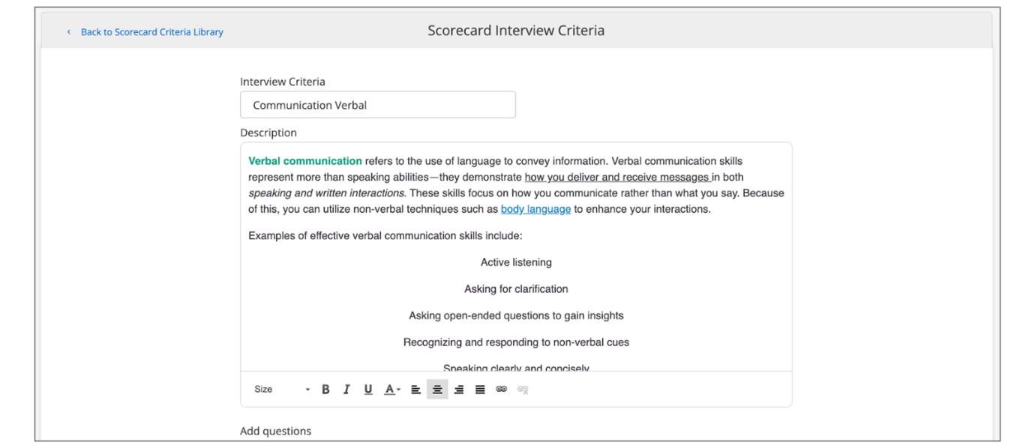
- You can build detailed descriptions for scorecards.
- You can format your descriptions by bolding, italicizing, underlining, aligning your content as well as changing font color and size.
- You can add hyperlinks to web pages or content directly into the scorecard descriptions. All hyperlinks open content in a new browser tab/page.
The formatting is retained when the scorecards are displayed on the jobs on the Hiring Process tab as well when you see the scorecards for evaluating candidates on the Reviews tab.
Org field filters: These will determine which jobs will automatically apply the scorecard criteria at the point of job creation. For example, if the scorecard criteria Programming Skills has Department = Engineering selected, then all jobs created where Department = Engineering will have Programming Skills added to their scorecard when such jobs are created. This will also apply to jobs that are created through the public API.
Assignment to Hiring Process/Hiring Steps: These will determine which specific hiring process and hiring steps this scorecard criteria will be assigned to. Therefore, only jobs meeting the org field filters criteria AND assigned hiring process criteria will see the scorecard show under Reviews, depending on which step of the process the scorecard was assigned to.
- This can be especially useful if the first round of the interview assesses one set of skills and the second round of the interview assesses a different set of skills.
Editable at job level: This toggle will control whether Hiring Teams can edit the scorecard criteria in the job, regardless of their scorecard permissions in Settings→Hiring Team Roles. If this toggle is set to on, Hiring Teams with edit scorecard permissions will be able to edit and/or delete the criteria after it has been added to the job. If this toggle is set to off, then the criteria cannot be edited or deleted from the job.
Any changes made to the criteria at the job level will not feed back to the library and will also not be visible in other jobs.
- This can be extremely useful to allow recruiters a degree of customization while still guiding the team towards a consistent approach.
Send changes to active jobs: This toggle, if selected, will apply the changes made to the criteria to all active jobs only. This will be helpful if there are minor edits such as spelling mistakes, clarifying information etc., to criteria. By default, this toggle will always be set as off each time you edit a criterion (meaning changes will only apply to newly created jobs). This is to avoid inconsistencies in the criteria used to review candidates for the same job.
Note
This option is exclusively for updating the criteria that are already assigned to jobs. This option will not add criteria to a job if it already exists. Sending changes to active jobs will not apply the criteria to a job that has not already been added to.
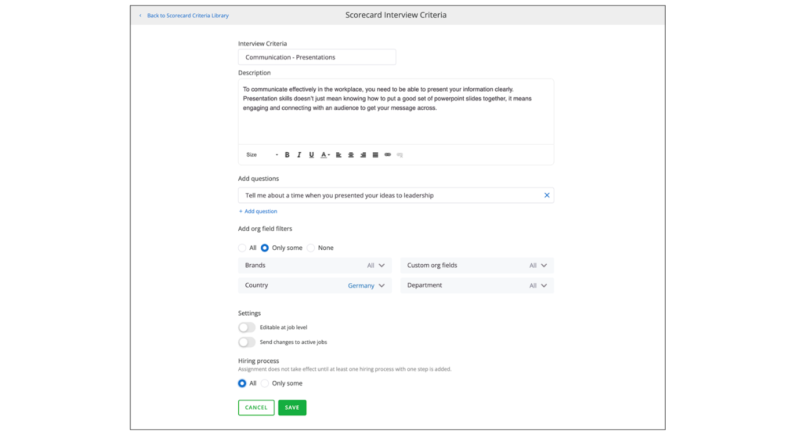
Scorecard criterion field character limits:
- Criterion name: max 200 characters
- Description: max 2000 characters
- Questions: max 200 characters
Create a New Scorecard Criteria
Steps
- Navigate to Settings.
- Select Scorecard Criteria Library within the Configuration section.
- Select Add New.
- Define the following criteria details:
  - Criteria Name
  - Description
  - Interview questions (optional)
  - Org field filters
  - Hiring Process and Hiring Step Assignment
  - Editable at job level (or not)
Once criteria are created and configured, they can be applied to specific jobs. When creating a job, you can select the relevant criteria to be included in the interview scorecard. You can also reorder the criteria to prioritize specific areas of focus during the interview process.
Edit Existing Scorecard Criteria
Steps
- Select the criteria you want to modify.
- Change the name, description, and questions.
- Determine whether the criteria should apply to all jobs, specific org fields, or none.
- Choose the hiring processes and steps to which the criteria should be assigned.
- Decide if recruiters can edit the criteria at the job level.
- Choose whether changes should apply to active jobs already using the criteria.
- Save your changes.
Note
All edits and deletions will not affect existing jobs and reviews. Changes will only be applied on an going-forward basis (for example, new jobs that are created after changes are made).
Create an Interview Scorecard
Steps
- Go to Settings/Admin.
- Under Configuration, select Scorecard Criteria Library.
- Here, you’ll see a list of existing scorecard criteria.
  - You can add questions to each criterion to guide the interviewer.
  - Criteria can be general topics or specific questions.
- Filter criteria based on job fields to ensure relevance:
  - All: The criteria will apply to all jobs.
  - Only Some: The criteria will be applied to jobs based on specific org fields (such as department, country).
  - None: The criteria will be available in the library but not automatically assigned to any job.
- Assign criteria to specific steps within a hiring process, allowing for granular control over when and where the criteria are used.
Scorecard Assignment to Hiring Process(es) and Hiring Step(s) from the Library
As an admin, you can set up the system to automatically assign scorecards to specific steps within hiring processes, so that only the associated scorecards will display under the Reviews for candidate evaluation tab when a candidate is on a given step in the hiring process. For admins, this will reduce their dependence on hiring managers or recruiters to set up scorecards for each individual job as well as reduce the amount of time it takes to do the assignment.
By default, scorecards will be set to All for the hiring process, meaning they will be assigned to all hiring processes and all steps under those hiring processes. You can see this under the Hiring Process section when adding or editing a scorecard in the library.
To customize the step assignment configuration, admins can select the Only Some option under the Hiring Process section and choose the specific hiring processes to associate with the scorecard.
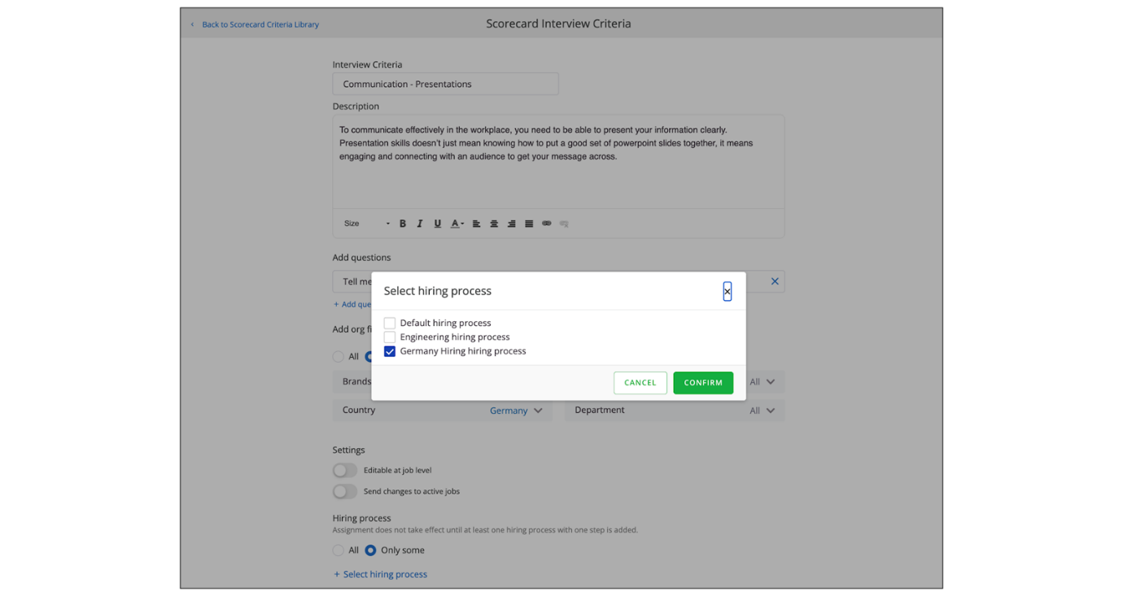
For each selected hiring process, admins can select the specific steps to associate with the scorecard. By default, when a hiring process is assigned to a scorecard, all steps under the hiring process are assigned to that scorecard (unless the admin changes the configuration).
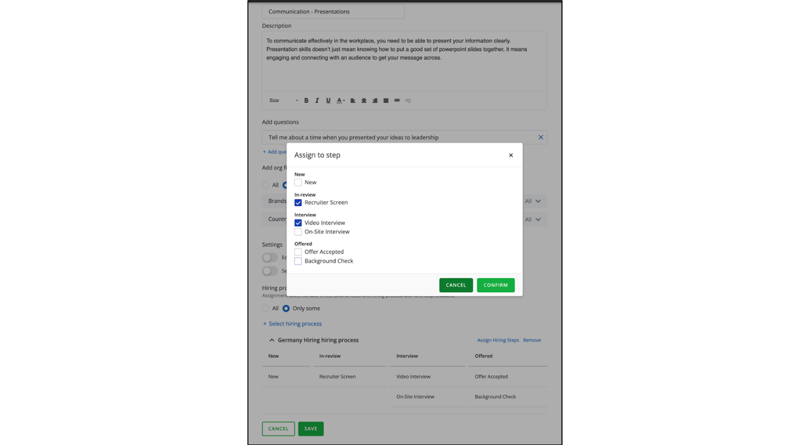
If a job matches the org field criteria as well as the associated hiring process, the scorecard will be added to the appropriate matching jobs based on the org field association and hiring process/step assignment that is configured. If a scorecard is assigned to hiring processes and steps but not tied to any org fields, it will not show up on any jobs. To honor the assignment and carry the scorecard into the jobs, the scorecard must satisfy both the org field configuration and the hiring step assignment configuration.
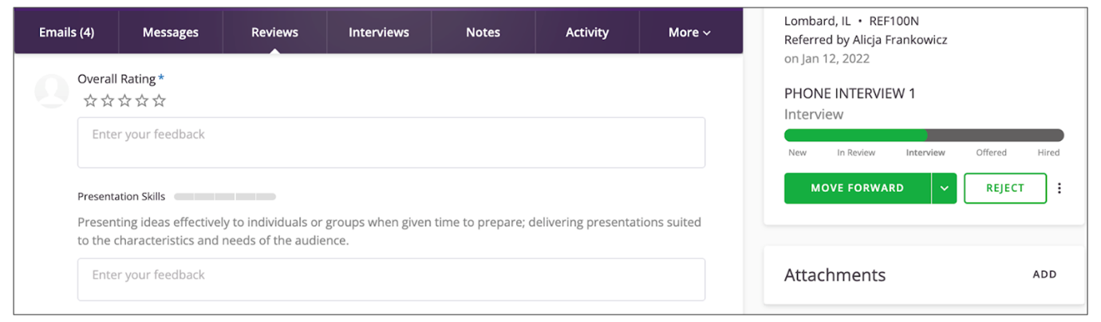
Assignment can be further modified for any job at the job level. Updating assignment of a scorecard does not disconnect the scorecard from the library.
If you choose to add a scorecard criterion to a job at the job level, then the assignment of it must also be configured at the job level; it will not carry over from the library based on the admin’s configuration. However, if the user does not specifically assign any steps when adding a scorecard to a job, the scorecard is assigned to all steps in the hiring process by default.
Note
Configurations apply only to new jobs created after the configuration was applied. It will not modify how the scorecards affect any existing jobs.
The video below provides more details about configuring interview scorecard criteria.
This video is for demonstration purposes. Any references made in this video to previous or later videos in this course (including titles, numbers, links, or sequence) may differ from the current course structure. Additionally, some functionalities shown may have evolved over time due to ongoing enhancements or business decisions.
Summary
- Interview scorecards provide a structured approach to candidate evaluation, ensuring consistency and focus during interviews.
- The Scorecard Criteria Library allows administrators to manage scoring criteria, including adding, editing, and deleting criteria without impacting existing jobs.
- Scorecard criteria can be configured with names, descriptions, interview questions, and organizational field filters.
- Criteria can be assigned to specific hiring processes and steps, allowing for granular control over when and where the criteria are used.
- Changes to scorecard criteria only apply to new jobs created after the changes are made, not to existing jobs.
Hi, in this video we're going
to be looking at how to create and configure interview
scorecard criteria. Interview scorecards can be found on the
Hiring Process tab of a job. If I scroll down you'll see
my interview scorecard here. Interview scorecards can be used
to help guide interviewers with criteria that needs to be covered during
the interview as well as questions that they can ask the candidate.
This overall helps drive consistency in your interviewing. You have
the ability to assign criteria to a hiring step so maybe there are
certain criteria or certain questions if you have multiple interviews
within your interview stage in your hiring process and you want different
criteria to be covered within each interview you can have the
criteria be assigned to a particular interview step in your hiring
process. So, for example, this interview criteria here would be covered in
the review or self-scheduled phone screen interview. If enabled
you can also add interview criteria to a job and here you would just
search for what you're looking for and you have the ability to
edit this at the job level if this is set up this way and
we'll look at that in a moment. You can add questions and you
can assign it to a hiring stop. Admins have the opportunity to
create interview criteria, but also have certain interview
criteria assigned to certain jobs. So to configure your
interview scorecard criteria, you're going to go to Settings and Admin, and under Configuration, we're going to click Scorecard Criteria Library. Here you'll see all of your existing
scorecard criteria that you have. If there are questions added to the
criteria, so maybe you have specific questions that you want the
interviewer to ask when reviewing this piece of the interview criteria,
you can add those questions here. Or you can have criteria with no
questions and it's more of just a general topic that they'll be
interviewing on. You can search your criteria up here. You can also apply
filters if you need to based on different job fields and then you
can also edit criteria as well. So for my training experience
criteria if I wanted to edit this I can change the name of the criteria.
I can change the description if I'd like. I can add or remove
questions so when this again like I said if this topic comes up in the
interview and there are specific questions that I want the
interviewers to ask for this criteria you can add those questions here
and then you can decide whether this criteria is going to be applied
to jobs based on their org field. So if I want this training experience
criteria to show up for every job because it's going to be asked
in interviews for any job that I have, I'm just going to keep it
at All. If I only have questions that are specific to a country
or specific to maybe a certain department, I can filter that so
that that criteria only shows up on jobs that are relevant to that org
field. So if I click only some, again like we've seen in other
places in the system, I can have this scorecard be driven by an org field.
So say if this was only applicable to the customer service department
I'm gonna have this piece of interview criteria only show up on jobs
that have the Department of Customer Service. And then if you want to
create criteria but you don't want it to automatically be added to
any job but you do want it to be available to be added if recruiters
if you give them the ability to add criteria to a job at the job level
you can click None. So again this is just going to allow this criteria
to live in your library but it's not going to assign this criteria
to any jobs. And then I can decide also along with org fields if I
want this question to be added to a particular hiring process. So since
this is training experience, since I wanted this only to show
up on customer service jobs, I can have that
this only shows up on the steps within a say high
volume hiring process. Once I choose the hiring process
then I can come and I can choose what steps I want this to be assigned
to so I can get very granular with where this criteria will show up
for an interviewer. I also have the option to limit who can edit this
criteria so as you saw in my example earlier I was able to add different
interview criteria from the job itself but maybe I don't want my
recruiters or users to be able to either remove or change or add
different scorecard criteria and in that case I would turn this off
and then I have the option to have the changes made to this existing
criteria apply to jobs that are active that already have this criteria
to them. So if I already have some jobs customer service jobs that have
the training experience criteria and I want to push these changes
out to those jobs that are active I can turn this on or if this is only
going to be for those jobs. Going forward I can leave this off but
I'm going to enable both of these and click Save. So that was editing
an existing criteria. You can also add criteria and as you start typing
you'll be given some options as far as what is already existing. So
you already have a time management criteria and this is again where
what I just did you can go in and edit this how you need or you can
create something completely new and then I can change this here to my new criteria or whatever
you want your description to be. Here is where I can add questions and just like how I showed I can assign
this to particular jobs with an org field or all jobs. I'll just
assign this to customer service again. I'm going to assign this to all
of my hiring processes or have it be available for all my hiring
processes and you'll notice that other option of save changes
is not here. That's because this is brand new but that option
of allowing the user to edit it at the job level is still here
so I'm gonna leave that on so now if I create a job that has a
customer service department set the department here and my information and save this. Now if I go look at my job I should see that customer service
criteria assigned and you'll see it here. Now you'll notice if I want
to move this to the top, maybe there's a specific
order I want my interviewers to ask certain questions
or look at criteria. I have the option to do that
and if I click reorder I can now either drag this or
just use the arrows to move it maybe to the top. So
maybe I want them to ask this first and I can do that
with other criteria as well. So that is how you can edit
or create new interview scorecard criteria in
SmartRecruiters. Thank you.
Setting Up Your Calendar Integration
Objective
After completing this lesson, you will be able to configure calendar integration and interview scheduling to streamline interviews and time management.
Calendar Integration in SmartRecruiters
An active calendar integration with SmartRecruiters allows coordinators, interviewers, and hiring managers to streamline their scheduling.
Calendar integration helps automate the scheduling of interviews and ensures there are no scheduling conflicts, allowing the system users (recruiters, hiring managers and others) to focus on the task at hand.
Benefits of Connecting Calendars to your ATS
- Automatic Scheduling: Your connected calendar automatically schedules interviews, preventing double-booking and ensuring availability is accurately reflected.
- Efficient Time Management: With your calendar integrated, you can manage your interview schedule and personal appointments seamlessly, all in one place.
- Streamlined Process: By connecting your calendar, scheduling becomes smoother, and you avoid manually updating the interviewers’ availability each time an interview is booked.
- Candidate Experience: Candidates report a positive experience with less back-and-forth when scheduling.
- Company-Level and User-Level Integration: Admins have the flexibility to configure calendar integration at both the company level and the individual user level:
- Company-Level Integration: Admins can set up a default calendar integration for the entire organization. Users do not need to perform additional setup to integrate their calendar if this option is chosen.
- User-Level Integration: Admins can allow individual users to choose which calendar provider they wish to integrate with SmartRecruiters (Google, Microsoft, or both). This option is ideal for users who may have a different calendar email address than their SmartRecruiters account email.
Hint
Best Practice - Consider how to roll out calendar accuracy and responsibility to all interviewers to ensure accurate information.
Calendar Integration Types
Calendar-Integrated User: A user whose SmartRecruiters account is linked to the same domain as the calendar integration. For example, if your organization’s calendar integration is set up with the domain @smartrecruiters.com, the calendar-integrated user’s SmartRecruiters account will also use this domain.
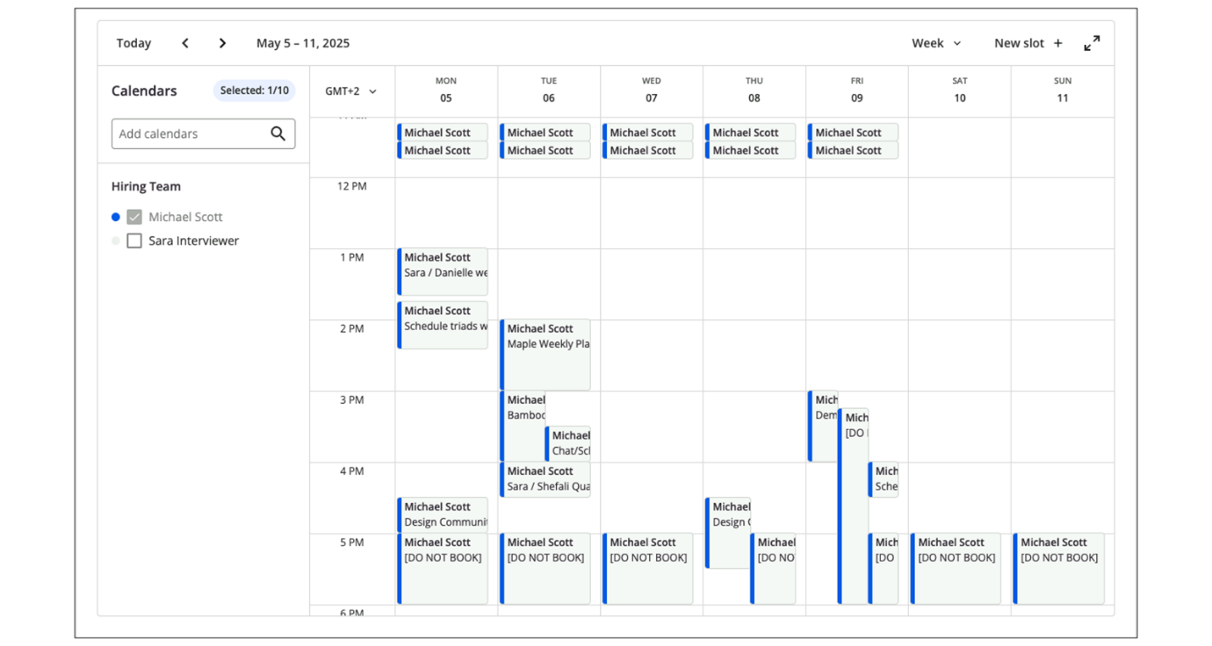
Non-Calendar-Integrated User: A user whose SmartRecruiters account is linked to a different domain than the one used for the calendar integration. For example, a user with an email address on @gmail.com or @example.com will be considered a non-calendar-integrated user if the calendar integration is set up for @smartrecruiters.com.
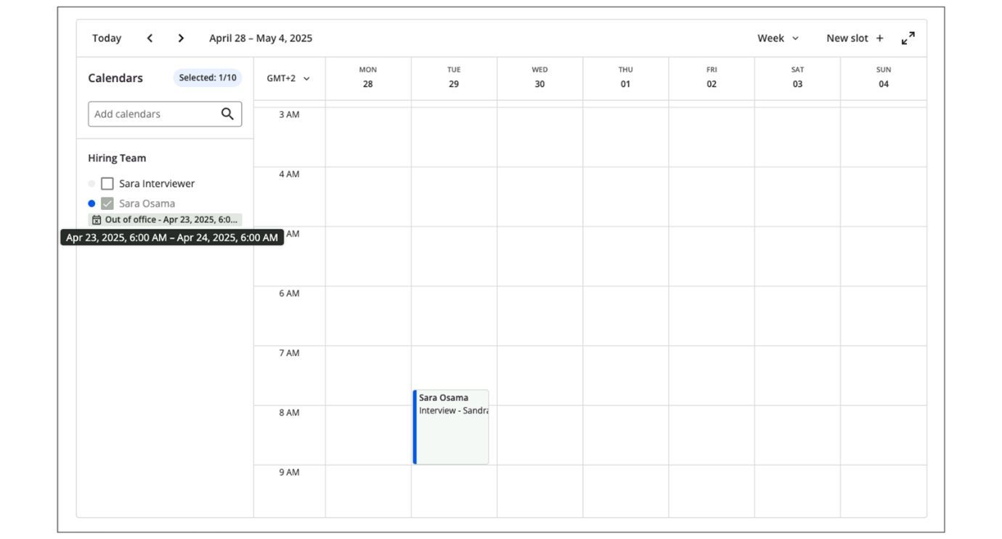
Per-User Calendar Integration: Separate Email Identity for Calendar Integration
The calendar integration allows users to configure a separate email address for their calendar that does not have to match their SmartRecruiters account email. This enhancement ensures that users with different email addresses for their SmartRecruiters account and their calendar (for example, Google or Microsoft Calendar) can still benefit from seamless integration.
SmartRecruiters assigns the correct email address for calendar integration, preventing conflicts or errors. The integration reliably fetches free/busy information, creates or updates calendar events, and receives event updates via webhooks without issue, even when the user’s calendar email differs from their SmartRecruiters email.
Integrated Interview Scheduling Features
Interview Invitation Email:
If the organizer/coordinator is a calendar-integrated user (such as Google, Office 365, or Exchange), interviewers will receive an email invitation from the calendar integration provider, not SmartRecruiters. This invitation typically includes an ICS file that can be added directly to the interviewer's calendar.
Direct Booking: The time slot is booked directly in the organizer's integrated calendar. Interviewers can easily accept or decline the invitation via multiple channels:
- From the UI: You can manage your interview status directly from your SmartRecruiters homepage, under Pending Interviews at the bottom right.
- From the Calendar: Interviewers can accept or decline the interview directly from their integrated calendar.
- From the Email: Interviewers can also accept or decline directly from the email notification they receive.
If the organizer/coordinator is a non-calendar-integrated user,interviewers will receive an email invitation from SmartRecruiters with the interview details and a link to accept or decline the interview. The interviewer's calendar won't automatically sync unless they accept the invitation.
Self-Scheduler:
With active calendar integration, both calendar-integrated and non-calendar-integrated users can access the self-scheduler. Here’s how it works:
- For calendar-integrated users: These users can see the availability of other calendar-integrated users on the self-scheduler. Additionally, their calendar events are displayed, providing a seamless scheduling experience.
- For non-calendar-integrated users: These users cannot see the availability of other users. However, an exception applies when the company uses Office 365 calendar integration with delegated permissions, allowing non-calendar-integrated users to view the availability of calendar-integrated users.
Bi-directional calendar sync:
Interview schedules often shift at the last minute, especially when the interviewer’s availability changes unexpectedly. In many cases, interview organizers make those changes directly in their calendar (Google, Office 365, or Exchange).
Bi-directional calendar sync gives companies the flexibility to handle these updates automatically. When enabled, changes made in the calendar, like adding or removing interviewers, can sync back into SmartRecruiters, reducing manual coordination and preventing miscommunication.
Configure Calendar Integration
Steps
- Navigate to the Settings page.
- Choose Apps & Integration.
- Select Calendar Integration from the available integrations.
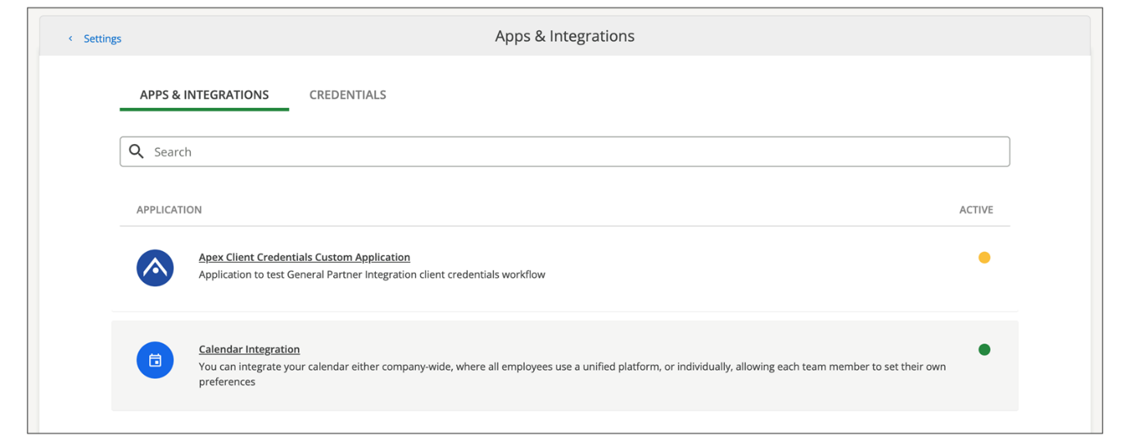
- Review Available Integration Types
  - Select the calendar integration type. Ensure the appropriate option for your organization is selected.
  - Select the calendar provider from the available list provided. Only one type can be selected from the following options:
    - Microsoft 365, or Microsoft 365 (Delegated permissions)
    - Microsoft Exchange
    - Google
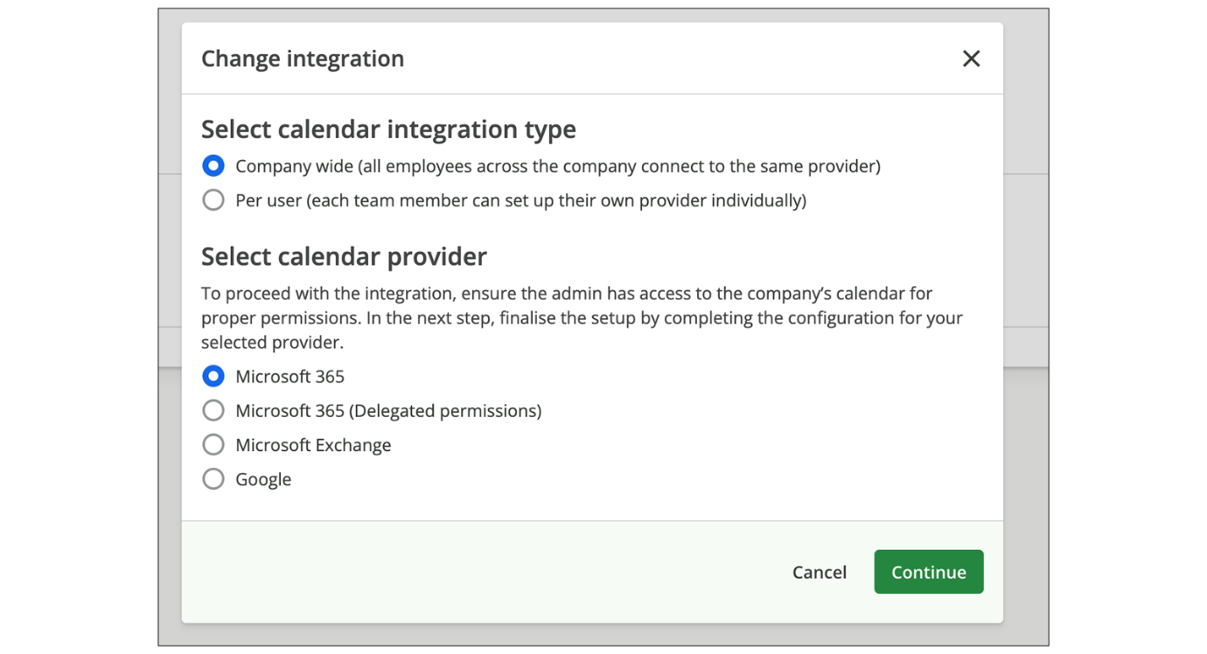
- Select Continue.
- Select from two available types of the integration and complete the configuration screen:
  - Company-wide: in this case, one type of integration will be applied to all users.
  - Per User integration: this allows users to individually connect their own calendar.
- Complete the configuration screens, where you can enable the integration.
- When you collapse the Settings area for Google or Microsoft 365 Calendars, select Enable for the calendar types you want to make available for your company users to connect individually.
Summary
- Calendar integration in SmartRecruiters streamlines the interview scheduling process and prevents scheduling conflicts.
- Admins can configure calendar integration at both the company level and the individual user level.
- SmartRecruiters supports calendar-integrated and non-calendar-integrated users.
- With active calendar integration, both types of users can access the self-scheduler.
- Bi-directional calendar sync allows changes made in the calendar to sync back into SmartRecruiters automatically.
Configuring Delegated Scheduling Preferences
Objective
After completing this lesson, you will be able to configure company-wide default scheduling and manage user-specific preferences.
Delegated Scheduling Preferences
Delegated Scheduling Preferences allow administrators to set company-wide defaults and manage individual user preferences, ultimately improving efficiency and supporting complex hiring operations. The functionality can be accessed through the Settings option.
Assign Access and Permissions
The Delegated Scheduling Preferences can be accessed by:
- System Administrators by default
- Delegated Admins with the Scheduling Management permission of Interview Templates & Scheduling Management
To assign this permission to a custom system role:
Steps
- Select User Menu→Settings.
- In the Permissions section, select System Roles.
- Edit the relevant custom role.
- Enable Interview Templates and Delegated Scheduling under Company Settings.
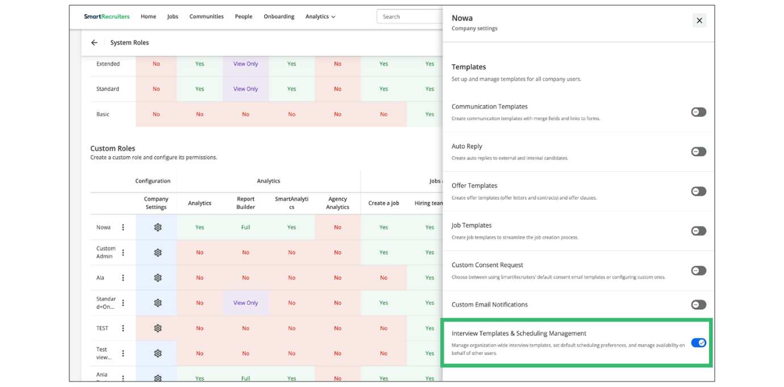
Set Up Company-Wide (Global) Default Scheduling Preferences
There are two options for setting up these preferences: Company-Wide (Global) Scheduling and Per User.
Company-Wide (Global) Default Scheduling Preferences allow administrators to define default availability rules for interview scheduling. These default settings apply to all users who have not yet customized their own scheduling preferences. This ensures consistent scheduling behavior across the organization, especially during feature rollout or onboarding new team members.
To set company-wide default scheduling preferences:
Steps
- Navigate to User Menu→Settings.
- In the Administration section, select Delegated Scheduling Preferences.
- In the Global tab, define the default scheduling automation preferences for the organization:
  - Preferred interview times: Specify the days and times when interviews are typically conducted (for example, Mon–Fri, 9am–5pm).
  - Advance and Buffer time settings: Configure the amount of advance notice required before an interview and the buffer time between interviews.
  - Daily interview limit: Set the maximum number of interviews a user can conduct in a single day.
- Select Save.
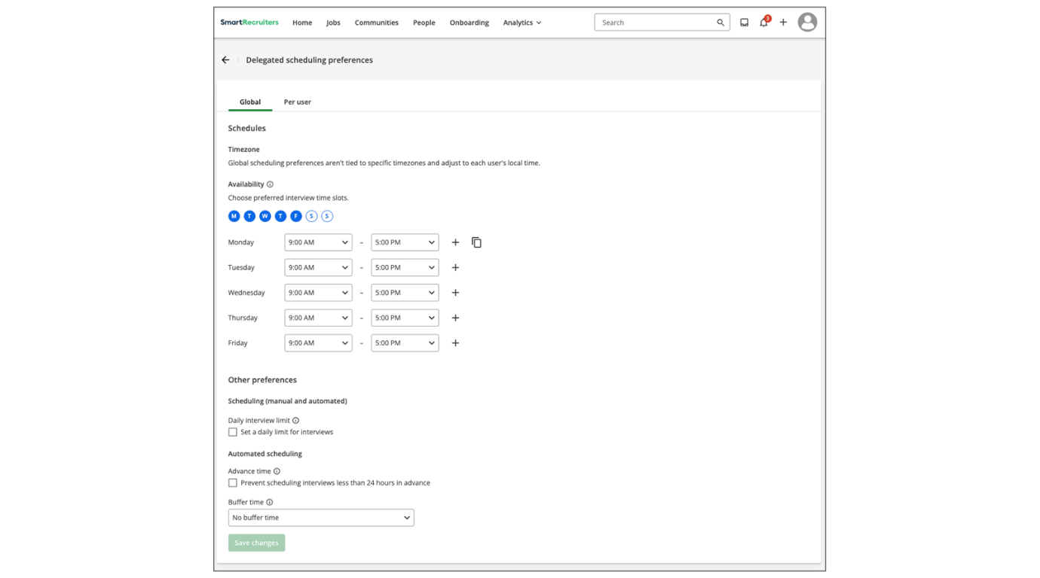
Note
These defaults only apply if users haven’t manually set their own preferences.
Set Up Scheduling Preferences for Other Users
Admins with the right permissions can view and edit scheduling preferences on behalf of other users.
This is useful when supporting executives, recruiters, or interviewers who don't have the time (or knowledge) to configure their availability themselves.
To enable the scheduling preferences per user:
Steps
- Select Menu→Settings.
- Select Delegated Scheduling Preferences in the Administration section.
- In the Per user tab, select the users you'd like to manage their scheduling preferences.
- Select a group of users and mark specific users as Favorites for quick access. (The next time you visit the page, you can easily filter the list to show only your favorites.)
- Select Edit scheduling preferences pen icon next to the user's name, or the button at the top of the table to manage the preferences of the selected users.
- You'll be able to fully manage the scheduling preferences of the selected users including:
  - Preferred interview times (e.g., Mon-Fri, 9am-5pm)
  - Advance and Buffer time settings between interviews
  - Daily interview limit
  - Date-specific availability
  - Out-to-office blocks
- Select Save.
Note
Admins cannot override user-defined preferences. They can only set preferences for users who haven't set them, or manually edit preferences on behalf of users via the Manage Individual Users section.
Once a user customizes their scheduling preferences under Settings→My Account→Scheduling Preferences, the company default no longer applies to them.
Summary
- Configuring company-wide default scheduling preferences ensures consistent interview scheduling across the organization for new users.
- Managing individual user preferences allows administrators to support users who need assistance with scheduling.
- These features streamline interview scheduling, improve efficiency, and support complex hiring operations.
ou.

